# **Name: Abdurrahman Qureshi**

# **Roll No: 210451**

Practical No: 4

**1) WAP to print “Hello World”**

**CODE:**

<?xml version="1.0" encoding="utf-8"?>  
<LinearLayout xmlns:android="http://schemas.android.com/apk/res/android"  
 xmlns:app="http://schemas.android.com/apk/res-auto"  
 xmlns:tools="http://schemas.android.com/tools"  
 android:layout_width="match_parent"  
 android:layout_height="match_parent"  
 tools:context=".HomePage"  
 android:orientation="vertical"  
 android:background="@color/black">  
 <LinearLayout  
 android:layout_width="match_parent"  
 android:layout_height="wrap_content"  
 android:background="@color/black"  
 android:layout_marginTop="300dp"/>  
 <TextView  
 android:layout_width="match_parent"  
 android:layout_height="wrap_content"  
 android:background="@color/black"  
 android:text="Hello World"  
 android:textColor="@color/white"  
 android:textAlignment="center"  
 android:textSize="50dp" />  
</LinearLayout>

**OUTPUT:**

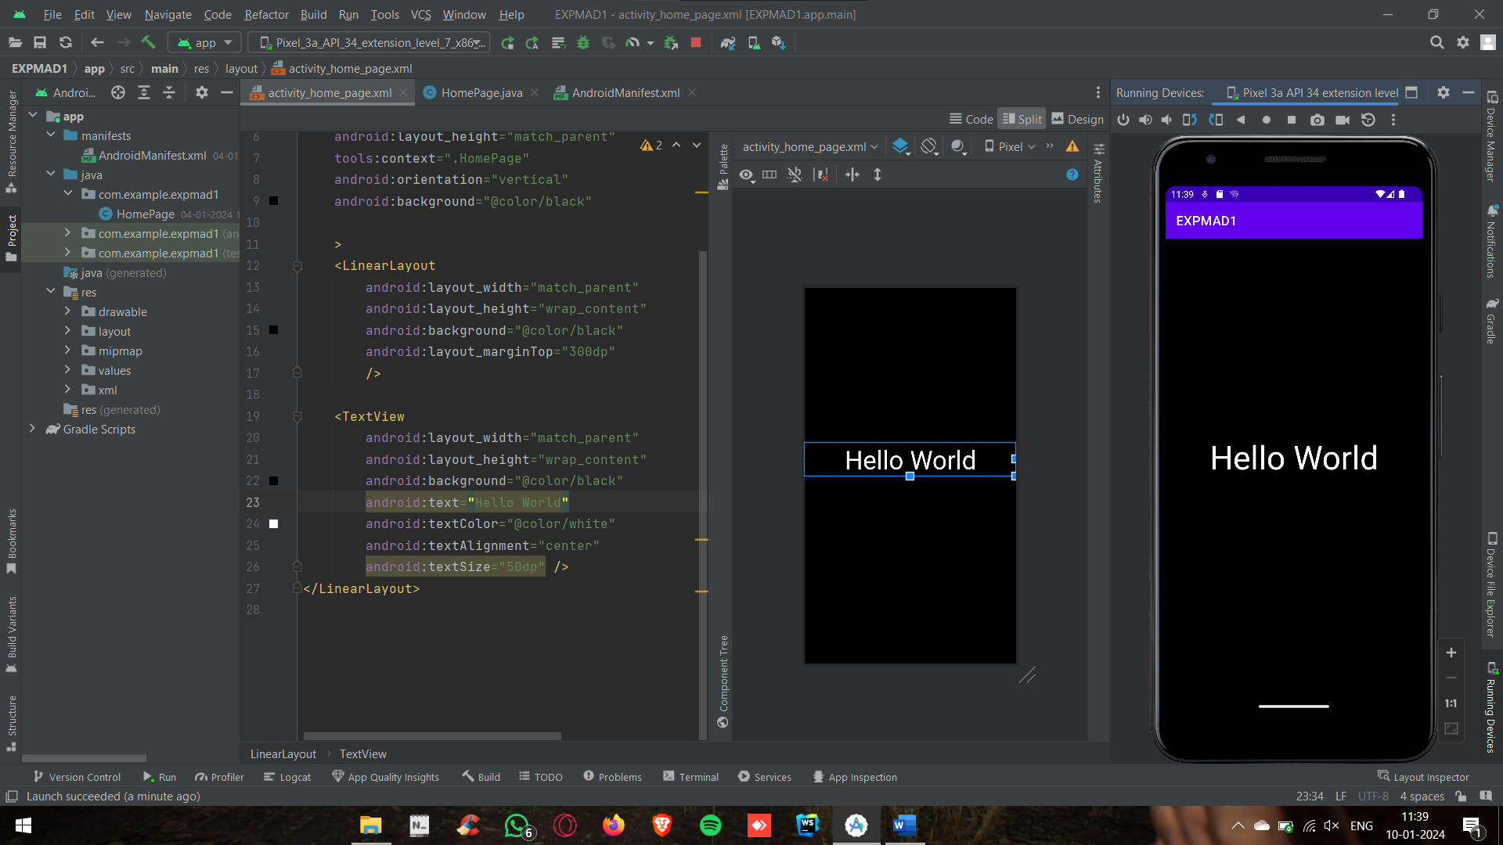

**2) WAP to print name and marks(percentage)**

**CODE:**

<?xml version="1.0" encoding="utf-8"?>  
<LinearLayout xmlns:android="http://schemas.android.com/apk/res/android"  
 xmlns:app="http://schemas.android.com/apk/res-auto"  
 xmlns:tools="http://schemas.android.com/tools"  
 android:layout_width="match_parent"  
 android:layout_height="match_parent"  
 tools:context=".HomePage"  
 android:orientation="vertical"  
 android:background="@color/black">  
 <LinearLayout  
 android:layout_width="match_parent"  
 android:layout_height="wrap_content"  
 android:background="@color/black"  
 android:layout_marginTop="300dp"0/>  
 <TextView  
 android:layout_width="match_parent"  
 android:layout_height="wrap_content"  
 android:background="@color/black"  
 android:text="qarq90"  
 android:textColor="@color/white"  
 android:textAlignment="center"  
 android:textSize="50dp" />  
 <TextView  
 android:layout_width="match_parent"  
 android:layout_height="wrap_content"  
 android:background="@color/black"  
 android:text="88.60%"  
 android:textColor="@color/white"  
 android:textAlignment="center"  
 android:textSize="50dp" />  
</LinearLayout>

**OUTPUT:**

